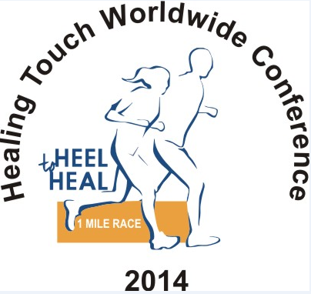

The race features:

- A 1 mile walk or run on a beautiful paved trail in the woods of Busse Park.

- A beautifully designed T-shirt special for conference.

- A dedicated website for registration and results.

- Sponsor listing will be on the webpage with a link back to their website.

- Shuttle to and from the park, which is just ¾ mile from the Hyatt Regency Hotel.

For more information contact:

Nancy Lavergne at 513-260-1273
CintiNancy@cinci.rr.com
Or
Jean Fudge
jaf529@earthlink.net

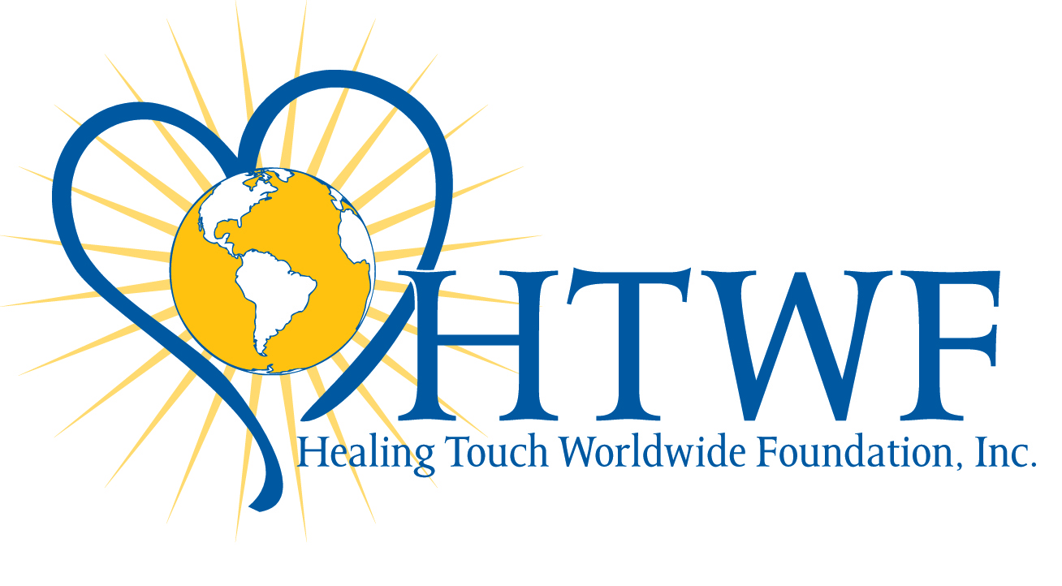
A non-profit 501c3 corporation
Tax ID 84-1460996

Healing Touch Worldwide Conference 2014
Heel to Heal 1 Mile Walk/Run
Chicago, IL
August 16, 2014

Please join us in sponsoring one of Healing Touch Worldwide Foundations (HTWF) exciting new fundraisers; the 1st Healing Touch Worldwide Conference Heel to Heal race. The event takes place at Busse Park Reserve just around the corner from conference at the Hyatt Regency Hotel.

Help raise $2,000 for HTWF
One Step at A Time!

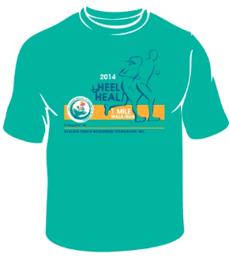

Picture your awesome company name or company logo on the back of the conference race T-shirt!
In order for the race to be a success, we need sponsors. Sponsorship levels start at $50!
Includes your company name on back of the T-shirt and one T-shirt or one race entry!
Sponsor deadline is required by July 1, 2014
(To allow time to process the T-shirts artwork.)

With your generous support, HTWF will continue to fund research, service and education initiatives, Spreading Healing Touch Worldwide.
One Step At A Time!

Sincerely,
Nancy Lavergne, Jean Fudge,
Event Director/Fundraising Chair Event Co-Chair
Healing Touch Worldwide Foundation, Inc.
Sponsorship levels

Contributing Level ($50)
- Listed as Contributing Sponsor
- Company Name on Event T-shirt back
- Company Name on Event Banner
- 1 complimentary race entry or T-shirt

Finish Line Level ($100)
- Listed as Finish Line Sponsor
- Company Name on event T-shirt back
- Company Name on Event Banner
- Larger font on T-shirt
- 2 complimentary race entries or T-shirts

Award Level ($200)
- Listed as Award Sponsor
- Company Logo on Event T-shirt back
(Logo must be provided by July 1st)
- Hand out medals to racers
- Largest font on T-shirt and banner
- Company logo on Event Banner
- 3 complimentary race entries or T-shirts

For complete race details go to:
https://HeeltoHeal.com

For more information contact:
Nancy Lavergne at 513-260-1273
CintiNancy@cinci.rr.com
Or
Jean Fudge
jaf529@earthlink.net

A non-profit 501c3 corporation
Tax ID 84-1460996 www.HTWFoundation.org
Healing Touch Worldwide Conference
2014
Heel to Heal 1 Mile Walk/Run
Chicago, IL
August 16, 2014

Sponsorship Levels
Please check which sponsorship level you would like:
_____ Contributing Sponsor ($50)
_____ Finish Line Sponsor ($100)
_____ Award Sponsor ($200)
Sponsor Information
Company Name ______________________________________
Contact Name _______________________________________
Address ____________________________________________
City _______________________________ Zip ____________
Phone ______________________________________________
Email_______________________________________________
Authorized Signature _________________________________
Date _______________
_____ My check is Enclosed $_______________
Your tax deductible gift made payable to: HTWF

_____ Pay online, at https://www.HeeltoHeal.com

_____ call in credit card info to Nancy 513-260-1273

_____ Please charge my Credit Card

Number: ____________________________________________

Expires ______________ Code __________

Signature _____________________________________

Please return this form/and payment to:
Nancy Lavergne
8219 Sweet Briar Ct, Liberty Twp., OH 45044

